**Internet of Things**

**INDEX**

|  |  |  |  |
| --- | --- | --- | --- |
| **Pract**  **No** | **Aim** | **Date** | **Signature** |
| **1** | Starting Raspbian OS, Familiarising  with Raspberry Pi Components and interface, Connecting to ethernet, Monitor, USB. |  |  |
| **2** | Displaying different LED patterns  with Raspberry Pi. |  |  |
| **3** | Displaying Time over 4-Digit 7-Segment  Display using Raspberry Pi |  |  |
| **4** | Controlling Raspberry Pi with Telegram. |  |  |
| **5** | IoT based Web Controlled Home Automation  using Raspberry Pi |  |  |
| **6** | Visitor Monitoring with Raspberry Pi  and Pi Camera |  |  |
| **7** | Interfacing Raspberry Pi with RFID. |  |  |
| **8** | Installing Windows 10 IoT Core  on Raspberry Pi |  |  |
| **9** | Raspberry Pi Based Oscilloscope |  |  |

**GPIO PINS**

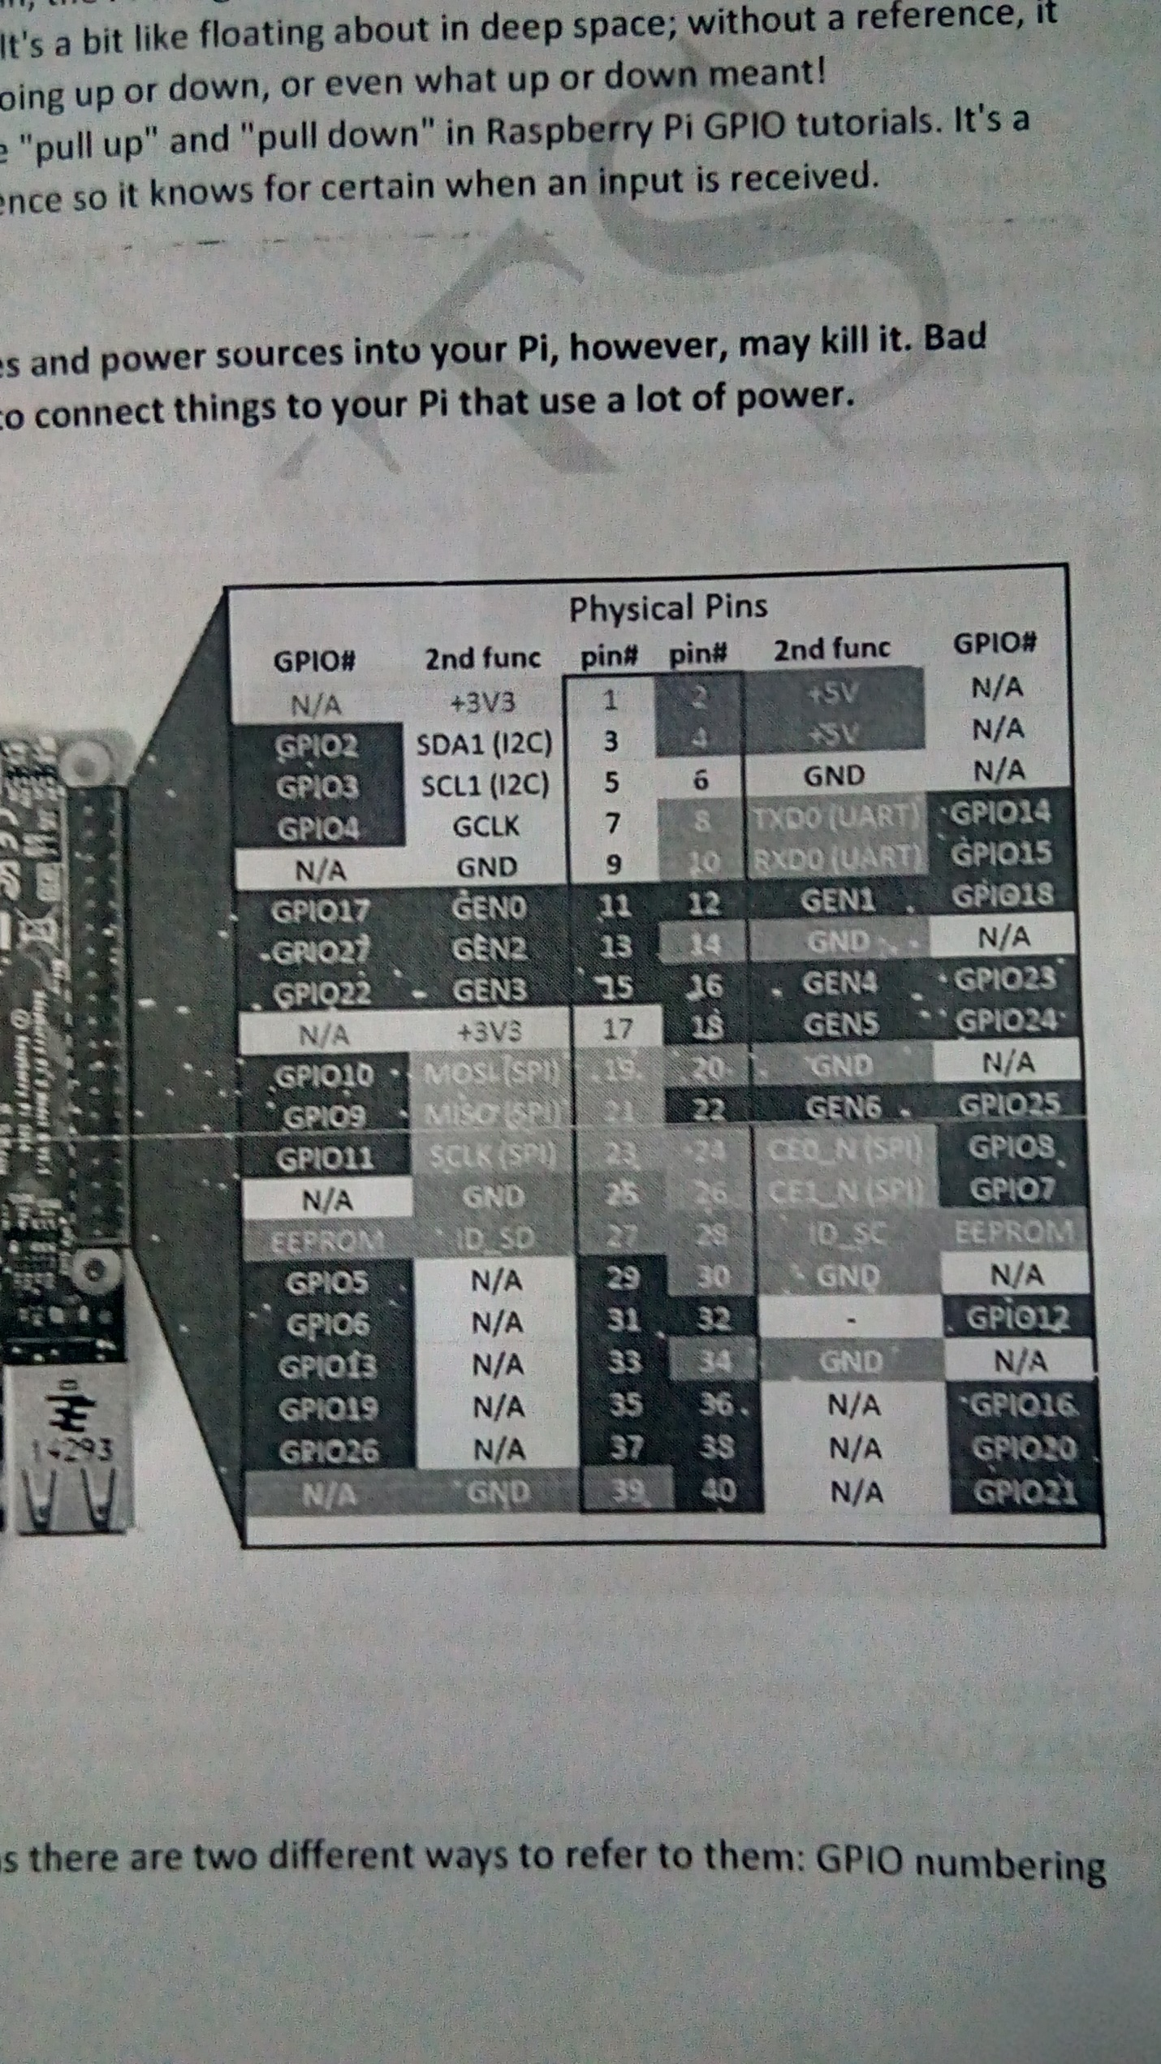

Hardware Components used:

**Raspberry Pi 3**

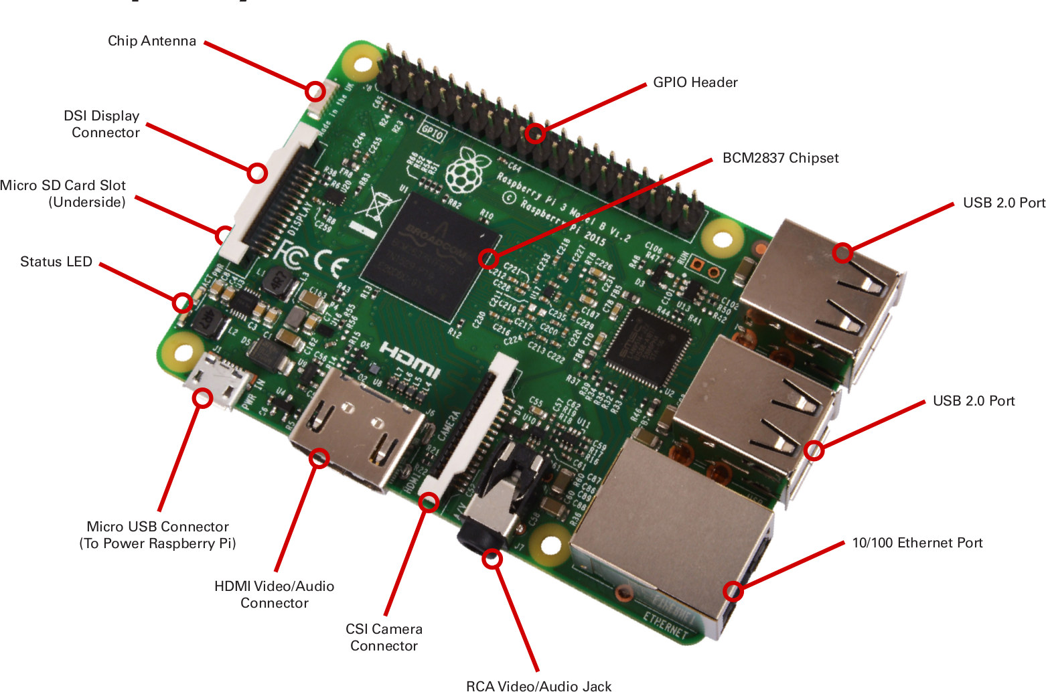

**BREAD BOARD**

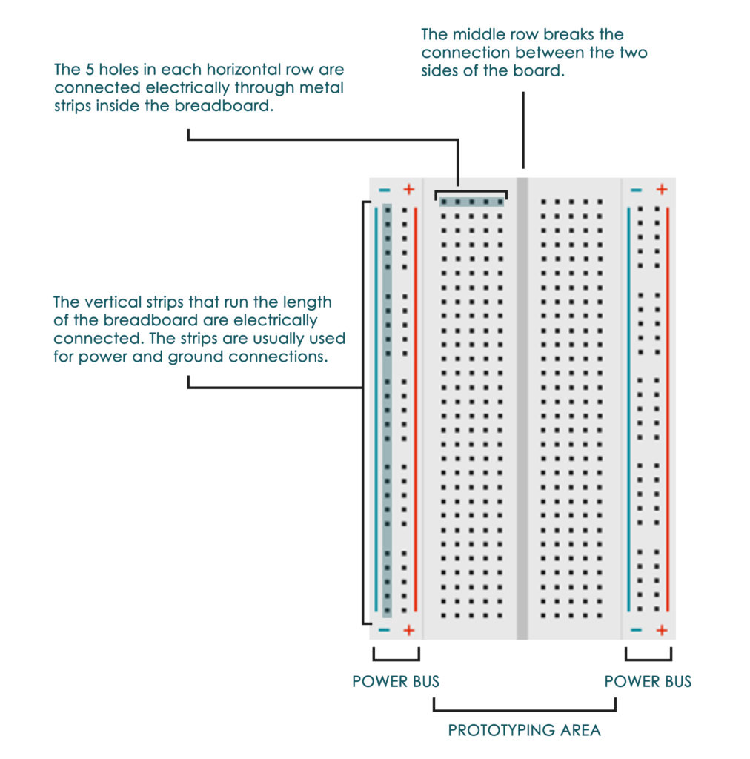

|  |  |
| --- | --- |
| Image result for raspberry pi camera module | Camera Module: |
| Image result for TM1637 4-digit seven segment Display boardRelated image | 4-digit 7-segment display module: |
| Image result for 5v relay module | 2 channel 5V relay module: |
| Image result for em-18 reader module with serial interface | RFID cards and Reader module: |
| Image result for ads1115 module | ADS115 module: |
| Image result for LED | LED: |
| Related image | Push button: |
| Image result for resistor 220 ohmImage result for resistor 10kImage result for resistor 1k | 220 K , 10 K and 1K resistors: |
| Image result for potentiometer | Potentiometer (POT): |
| Image result for jumper wires typesImage result for jumper wire female to female | M-F and F-F jumper wires: |
| Image result for usb to ttl converter | USB to TTL converter: |

**Practical 1**

**Aim:**

**Starting Raspbian OS, Familiarising with Raspberry Pi Components and interface, Connecting to ethernet, Monitor, USB.**

**Accessories needed:**

1. **Raspberry Pi**
2. **A power supply**
3. **An HDMI cable**.
4. **A USB mouse and keyboard**.
5. **An SD memory card**.
6. **An SD memory card reader**.
7. **Internet connection. (Ethernet or wireless)**

**Steps to make bootable SD card for Raspberry Pi (raspbian stretch)**

**1: Get raspbian OS on your micro SD card:**

1. Download raspbian from raspberrpi.org and click download and then click on Raspbian (select Raspbian Strech with desktop file.) mostly as zip file.

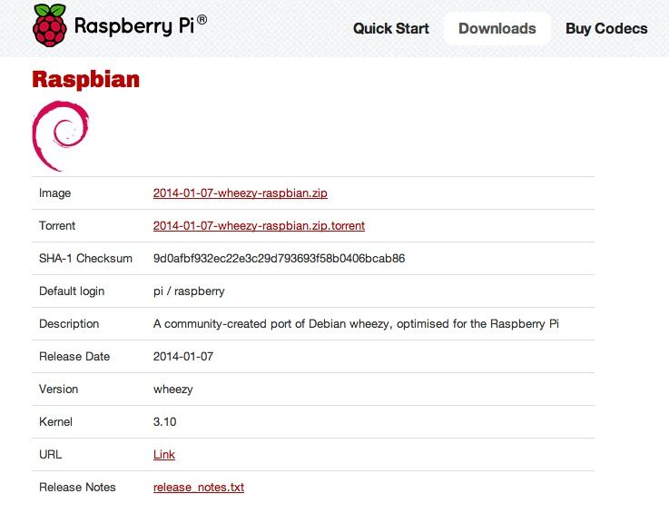

1. Unzip file to find a disc image.
2. Format new SD card using SD Formatter tool.
3. You need to install Win32DiskImager tool to write image to SD card.
4. In Win32DiskImager tool select image file and click Write button.

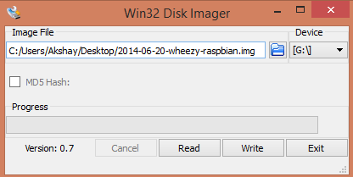

1. Once it is written your card name will change into boot.
2. Now can insert this card in your Raspberry Pi.

**2: Configuring Pi:**

Raspberry Pi comes with a default user name and password and so always use it whenever it is being asked. The credentials are:

login: pi

password: raspberry

When the Pi has been booted for the first time, a configuration screen called the "Setup Options" should appear and it will look like the image below.

We can open this window with

sudo raspi-config

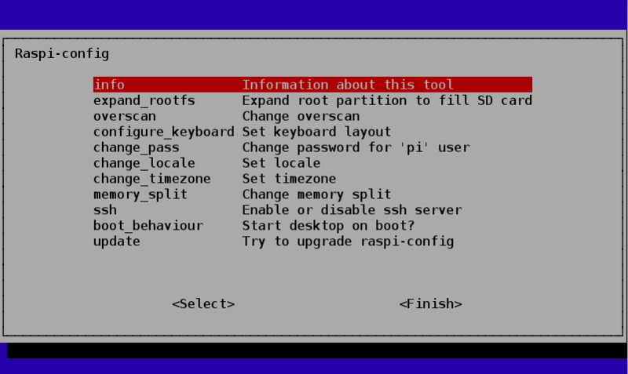

* change_locale – For non-English speakers, you can select which locales should be available on the system and which should be the default for the operating system.

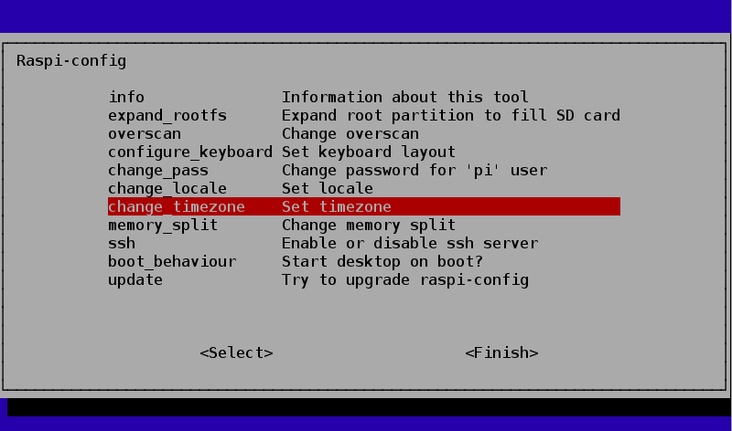

first select the Geographic Area as **ASIA**

then the Timezone within that area as **Kolkata.**

**Alternate Option:**

**Using the Raspberry Pi Configuration tool**

Presently, the Raspberry Pi Configuration tool displays four tabs:

* System. Options to expand the file system and change password and hostname sit alongside various login choices.
* Interfaces. Support for the various hardware and software features, such as Camera Module, SSH, and VNC.
* Performance. Overclocking and GPU memory options can improve the performance of a Raspberry Pi.
* Localisation Set up an international keyboard, global WiFi options, and adjust the locale and time zone.

### Interfaces Tab

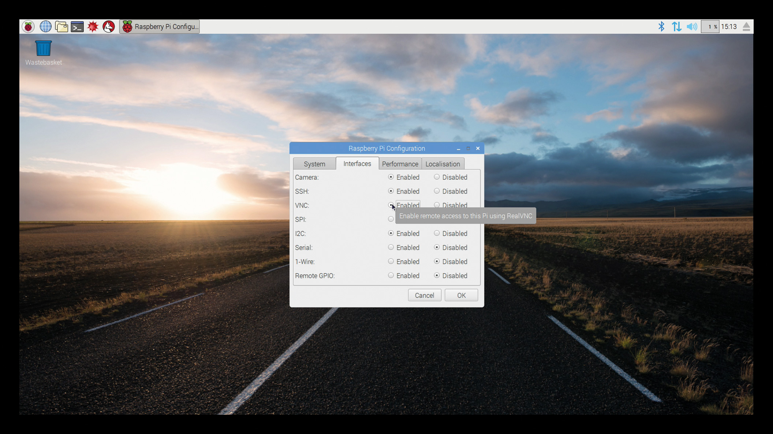

### Localisation Tab

### Set Locale option

### Image result for raspberry pi configuration tool localization

### Set Timezone option

### Image result for raspberry pi configuration tool localization

### Select location as Kolkata

### Set keyboard option

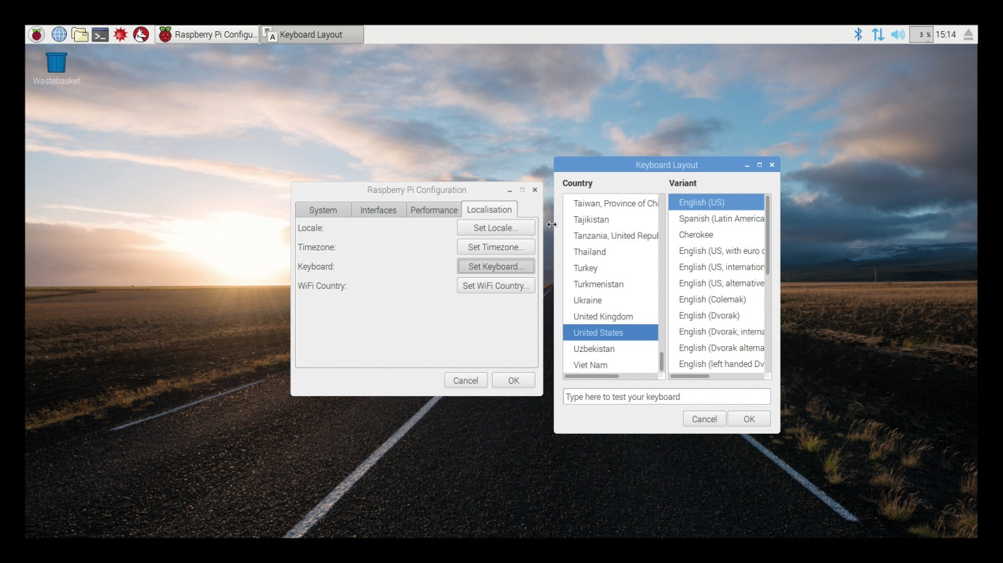

1. **Set WiFi country option**

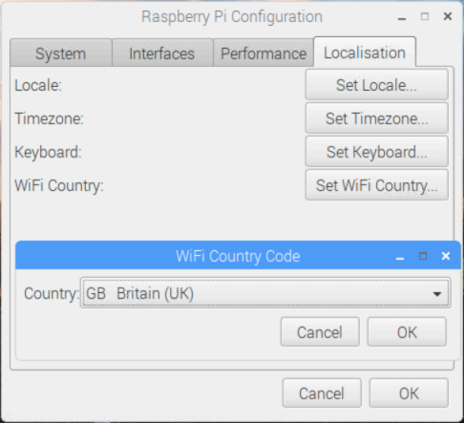

**Select INDIA here**

**Practical 2**

**Aim:**

**Displaying different LED patterns with Raspberry Pi.**

**Additional Hardware required:**

1. Resistors
2. LEDs
3. Jumper wires
4. Breadboard

**Connections:**

1. Connect LEDs on breadboard
2. Connect resistor to one end of led (to Positive end or anode).
3. Connect other end of resistor to GPIO pin on raspberry Pi.
4. Connect other end of LED to ground (negative end or cathode).

**Write following code in Python IDLE 3 save it as ‘pattern.py’**

import RPi.GPIO as GPIOfrom time import sleep

GPIO.setmode(GPIO.BOARD)

led1=29led2=31led3=33led4=35

GPIO.setup(led1,GPIO.OUT)GPIO.setup(led2,GPIO.OUT)GPIO.setup(led3,GPIO.OUT)GPIO.setup(led4,GPIO.OUT)

GPIO.output(led1,False)GPIO.output(led2,False)GPIO.output(led3,False)GPIO.output(led4,False)

def ledpattern(v1,v2,v3,v4): GPIO.output(led,v1) GPIO.output(led,v2) GPIO.output(led,v3) GPIO.output(led,v4)

try: while True: for in in range(0,5): ledpattern(1,0,0,0) time.sleep(0.5) ledpattern(0,1,0,0) time.sleep(0.5) ledpattern(0,0,1,0) time.sleep(0.5) ledpattern(0,0,0,1) time.sleep(0.5)finally: GPIO.output(led,False) GPIO.cleanup()

**Output:**

Glowing LED1



Glowing LED2 Glowing LED3

 

**Practical 3**

**Aim:**

**Displaying Time over 4-Digit 7-Segment Display using Raspberry Pi**

**Additional Hardware requires:**

1. TM1637 4-digit seven segment Display board
2. Jumper wires

**Pins connection**

| TM1637 Pin | Name | Remarks | RPi Pin | RPi Function

|----------:|:-----|:------------|--------:|-------------------

| 1 | GND | Ground | 6 | GND

| 2 | VCC | +5V Power | 2 | 5V

| 3 | DIN | Data In | 38 | GPIO 20

| 4 | CLK | Clock | 40 | GPIO 21

**Libraries needed:**

tm1637.py is a driver library. Download and save it in same folder as your code.

**Write following code in Python 2 IDLE save it as ‘clock.py’**

from time import sleepimport tm1637

try:

import thread

except ImportError:

import _thread as thread

Display = tm1637.TM1637(CLK=21, DIO=20, brightness=1.0)

try:

print "Starting clock in the background (press CTRL + C to stop):"

Display.StartClock(military_time=True)

sleep(1)

Display.ShowDoublepoint(False)

sleep(5)

Display.StopClock()

thread.interrupt_main()except KeyboardInterrupt:

Display.cleanup()

**Output:**



**Practical 4**

**Aim:**

**Controlling Raspberry Pi with Telegram.**

**Additional Hardware Required:**

1. LED
2. Breadboard
3. Resistor
4. Jumper wires

**Software required:**

On Mobile Phone: Telegram

**Steps**

**1: Download Telegram from playstore on your android phone.**

**2: Install Telegram.**

**2: Open Telegram app in your system or mobile**

**3: Click On Start Messaging Button**

**4: Enter your mobile number to register with telegram service.**

**5: Search for name "BotFather"**

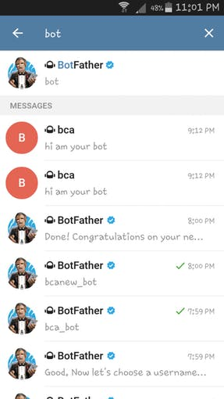

**6: Click on "BotFather**

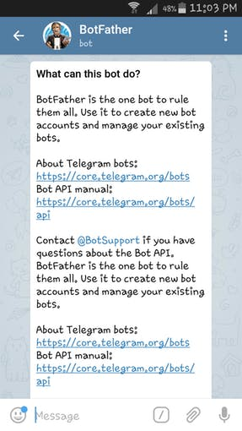

**7: To Start "BotFather" type /start in message**

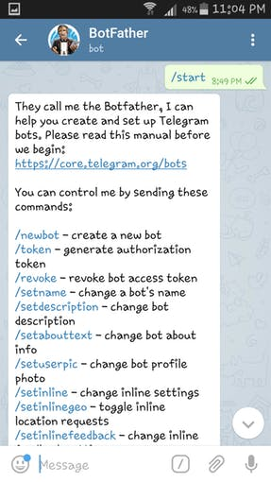

8: Now type /newbot in message . and then give name to your BOT and Username also.



9: **Obtain access token**

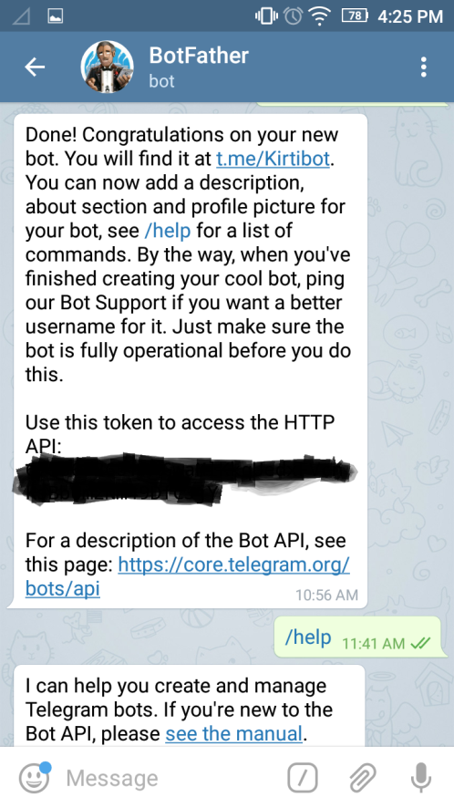

This same token we are supposed to use in our code in raspberry pi to connect to our BOT.

**Set up On Raspberry Pi:**

**1: Install "Python Package Index" and Telepot using :**

sudo apt-get install python-pip

sudo pip install telepot

**2: Test your bot using python 2 IDLE and type:**

import teleport

bot = telepot.Bot('Bot Token')

bot.getMe()

If it prints your bot details means everything is correct.

If not then token is wrong.

**Write the following code in Pyhton 2 IDLE and save it as ‘mybot.py’**

import sys

import time

import random

import datetime

import telepot

import RPi.GPIO as GPIO

GPIO.setmode(GPIO.BOARD)

GPIO.setup(11, GPIO.OUT)

def handle(msg):

chat_id = msg['chat']['id']

command = msg['text']

print 'Got command:', command

if command == 'on':

bot.sendMessage(chat_id, "LED on")

GPIO.output(11,GPIO.HIGH)

elif command =='off':

bot.sendMessage(chat_id, "LED off")

GPIO.output(11,GPIO.LOW)

elif command == 'stop':

exit()

try:

bot = telepot.Bot('Bot Token')

bot.message_loop(handle)

print 'I am listening...'

while 1:

time.sleep(10)

except TelegramError:

print ' '

Note: do not forget to replace ‘Bot Token’ with your token received from telegram.

**Output:**

Connections:



Output on python IDLE:

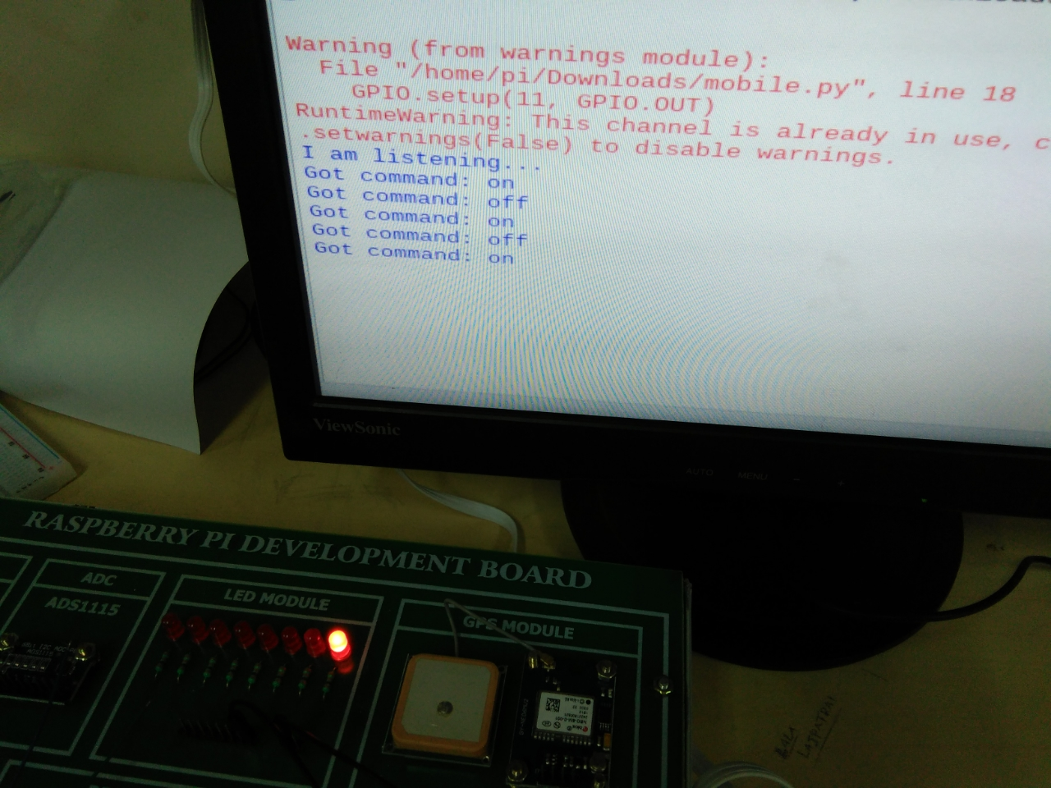

Output on Telegram (Mobile phone):

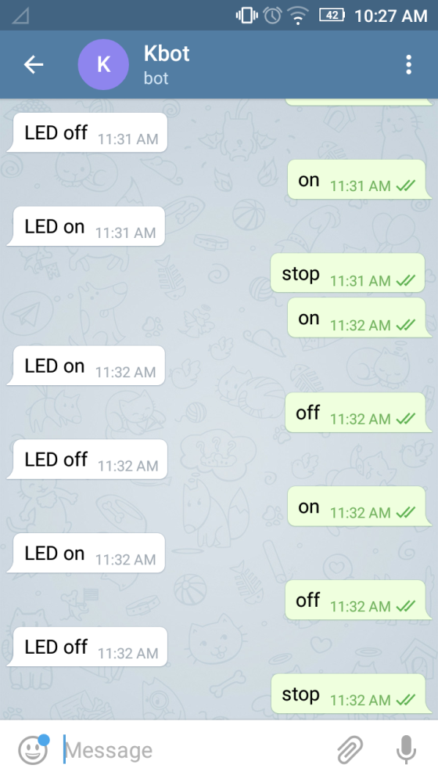



**Practical 5**

**Aim:**

IoT based Web Controlled Home Automation using Raspberry Pi

**Additional Hardware Required:**

1. 5v Relay
2. External 5V supply (adapter)
3. Jumper Wires
4. AC lamp
5. Fan
6. External 220 v supply board with connections for LAMP and FAN

**Software Required:**

**WebIOPi**

**Connections:**

1: Connect Relay Module to external 220 V board.



This is for one device for one more device connect other part with other wire in same way.

2: connect external +5v to VCC pin of relay module.

3: connect external -5v to GND pin of relay module.

4: connect next individual GND pin of relay module with ground of Pi (say pin 39)

5: connect IN1 pin of relay module to PIN 35 of Pi

6: connect IN2 pin of relay module to PIN 37 of Pi

**Steps to set up WebIOPi:**

**1: Run following commands in Terminal:**

sudo apt-get update

sudo apt-get upgrade

sudo reboot

cd ~

**2: download zip file using:**

wget http://sourceforge.net/projects/webiopi/files/WebIOPi-0.7.1.tar.gz

**3: When download is done, extract the file and go into the directory**

tar xvzf WebIOPi-0.7.1.tar.gz

cd WebIOPi-0.7.1/

**4: install a patch as this version of the WebIOPi** does not work with the raspberry pi 3

wget https://raw.githubusercontent.com/doublebind/raspi/master/webiopi-pi2bplus.patch

patch -p1 -i webiopi-pi2bplus.patch

**5: run the setup installation for the WebIOPi using**

sudo ./setup.sh

Keep saying yes if asked to install any dependencies during setup installation. When done, reboot your pi using:

sudo reboot

**6: Test WebIOPi Installation:**

sudo webiopi -d -c /etc/webiopi/config

**7: point the web browser of your computer connected to the raspberry pi to http://thepi’sIPaddress:8000**

[use hostname –I to find IP address of Pi]

**8: The system will prompt you for username and password**

Username is *webiopi*

Password is *raspberry*

After the login, look around, and then **click on the GPIO header link**.



And set the PINs that you want to use As OUT

**In our code PINS are 35 and 37 so set then to OUT**

**Now click on these pins one by one to ON/OFF lamp and fan.**

Once you are done using it press Ctrl+C on terminal and stop service from running using;

sudo /etc/init.d/webiopi stop

**Output:**



Output after clicking on buttons on WebIOPi:



**Practical 6**

**Aim:**

**Visitor Monitoring with Raspberry Pi and Pi Camera**

**Additional Hardware Required:**

1. Pi camera
2. DC Motor
3. IC L293D
4. Bread Board
5. Resistor (1k,10k)
6. Push Button
7. Jumper wires
8. External 5V supply (adapter)

**Connections:**

1: connect Pi camera to Raspberry Pi by removing case like following: (pull out slot , Insert camera in , Press slot again properly)

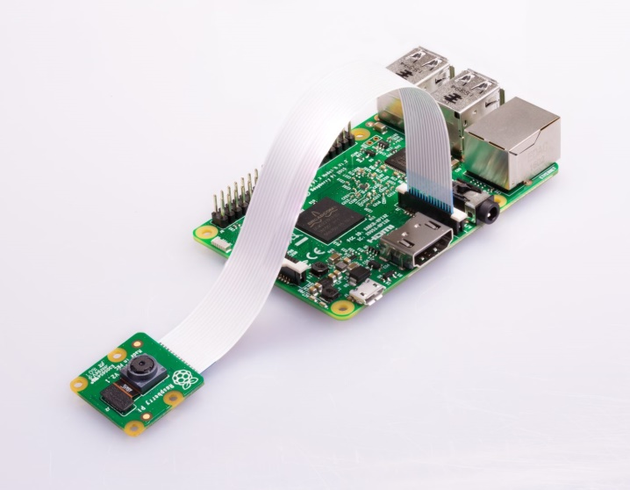

2: connect DC motor to L293D driver module with screw driver.

3: connect push button of Breadboard.

4: connect on leg of push button to Resistor (Brown Black Orange ) 10K.

**Jumper wire Connections:**

1: connect driver module A1 pin to Pin 11 of Pi.

2: connect driver module A2 pin to Pin 13 of Pi.

3: connect driver module EN pin to external +5v taken on breadboard.

4: connect driver module VCC pin to external +5v taken on breadboard.

5: connect driver module GND pin to external -5v taken on breadboard.

6: connect pin 25 on Pi to pushbutton leg which is not connected to resistor.

7: connect pin 35 on Pi to pushbutton leg which is also connected to resistor.

8: connect pin 1 on Pi to other leg of resistor which is not connected to pushbutton.

9: make common ground by connecting Pin 6 on Pi to external -5v taken on breadboard.

**Software configuration:**

**1.install Pi camera library files**

$ sudo apt-get install python-picamera

$ sudo apt-get install python3-picamera

**2. Configuration Tool (raspi-config):**

$ sudo raspi-config

**3. Then select Enable camera and Enable it.**



**4. reboot Raspberry Pi**

$ sudo reboot

**Write following code in Python 3 IDLE and save it as ‘MyCamera.py’**

import time

import picamera

import RPi.GPIO as gpio

m11=17

m12=27

button=19

gpio.setwarnings(False)

gpio.setmode(gpio.BCM)

gpio.setup(m11,gpio.OUT)

gpio.setup(m12,gpio.OUT)

gpio.setup(button,gpio.IN)

gpio.output(m11,0)

gpio.output(m12,0)

def capture_image():

camera.resolution=(1280,720)

camera.start_preview()

time.sleep(2)

camera.capture('/home/pi/Pictures/myimg.jpg')

camera.stop_preview()

print('done')

def gate():

gpio.output(m11,1)

gpio.output(m12,0)

time.sleep(1.5)

gpio.output(m11,0)

gpio.output(m12,0)

time.sleep(3)

gpio.output(m11,0)

gpio.output(m12,1)

time.sleep(1.5)

gpio.output(m11,0)

gpio.output(m12,0)

time.sleep(2)

time.sleep(1)

camera=picamera.PiCamera()

camera.rotation=180

camera.awb_mode='auto'

camera.brightness=55

time.sleep(2)

while 1:

print('Press button to capture image')

if gpio.input(button)==0:

capture_image()

gate()

time.sleep(0.5)

[Note: run the code and press button on breadboard to capture image]

**Output:**



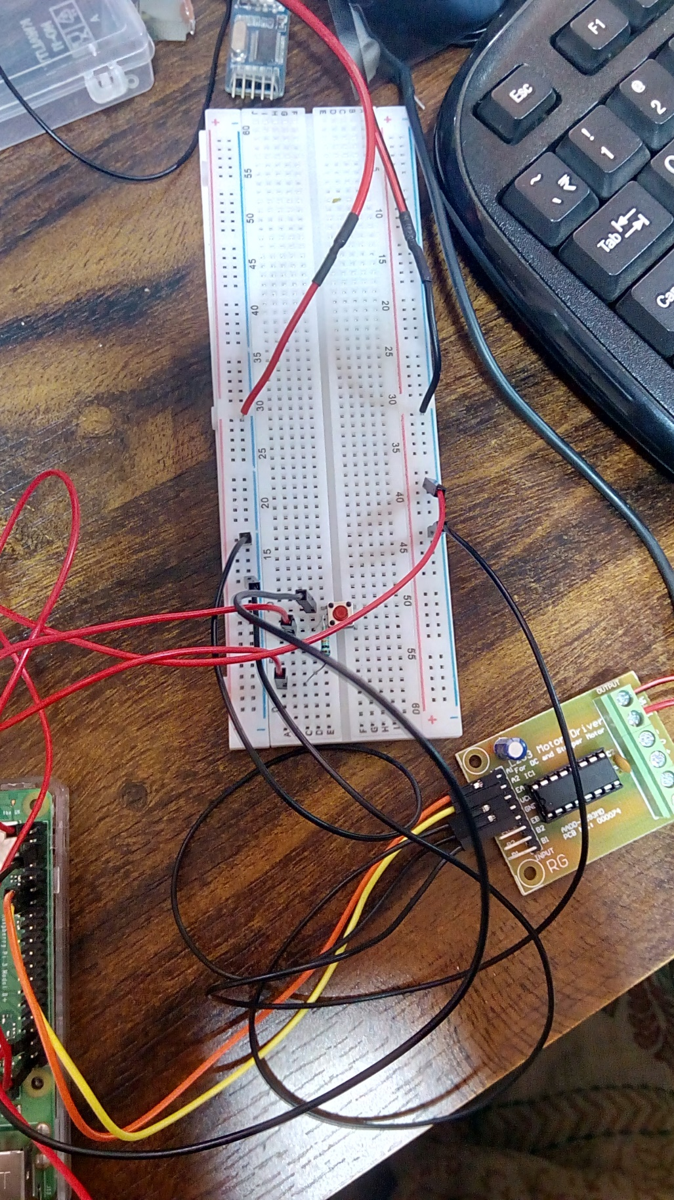

**Practical 7**

**Aim:**

**Interfacing Raspberry Pi with RFID.**

**Additional Hardware Required:**

1. EM-18 RFID Reader Module
2. USB-To-TTL converter
3. Few RFID Cards or RFID Tags
4. 5V external Power Supply for RFID Reader
5. Jumper Wires

**Connections:**

1: connect Tx pin of RFID module to Rx pin of USB-to-TTL converter.

2: connect GND (not the centre one) pin of RFID module to GND pin of USB-to-TTL converter.

3: connect positive pin (down side) of RFID module to External +5v pin of adapter.

4: connect negative pin (down side) of RFID module to External +5v pin of adapter.

5: Finally connect USB-to-TTL converter into USB port of raspberry pi.

**Software configurations:**

**Setting up Raspberry Pi for Serial Communication**

sudo raspi-config

In the “Interfacing Options”, select the “Serial” option.



Select “Yes” option.

Finish the process and Reboot the Raspberry Pi.

**To check your USB port number use following command:**

ls /dev/ttyUSB*

In following code it is ttyUSB0

**Write the following code in Python 2 IDLE and save it as ‘rfid.py’**

import time

import serial

data=serial.Serial(port='/dev/ttyUSB0',baudrate=9600,parity=serial.PARITY_NONE,

stopbits=serial.STOPBITS_ONE,bytesize=serial.EIGHTBITS)

try:

while 1:

print "Place the card"

x=data.read(12)

print(x)

if x="1C00377ACC9D"

print "Access Granted"

else:

print "Access Denied"

except KeyboardInterrupt:

data.close()

[Note: now place the RFID cards one by one over RFID module to check the output]

**Output:**

Output on Python IDLE:

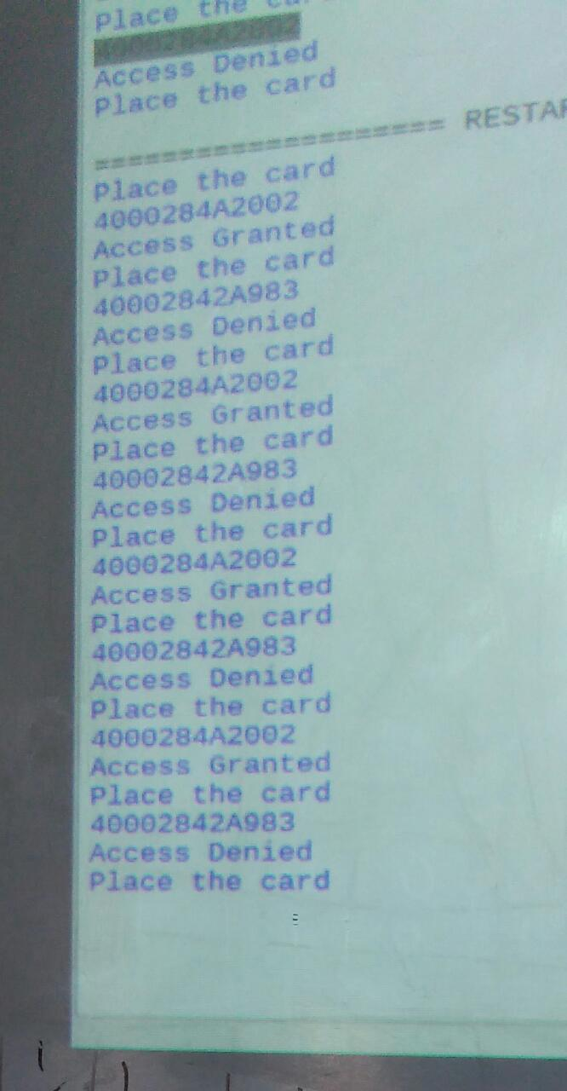

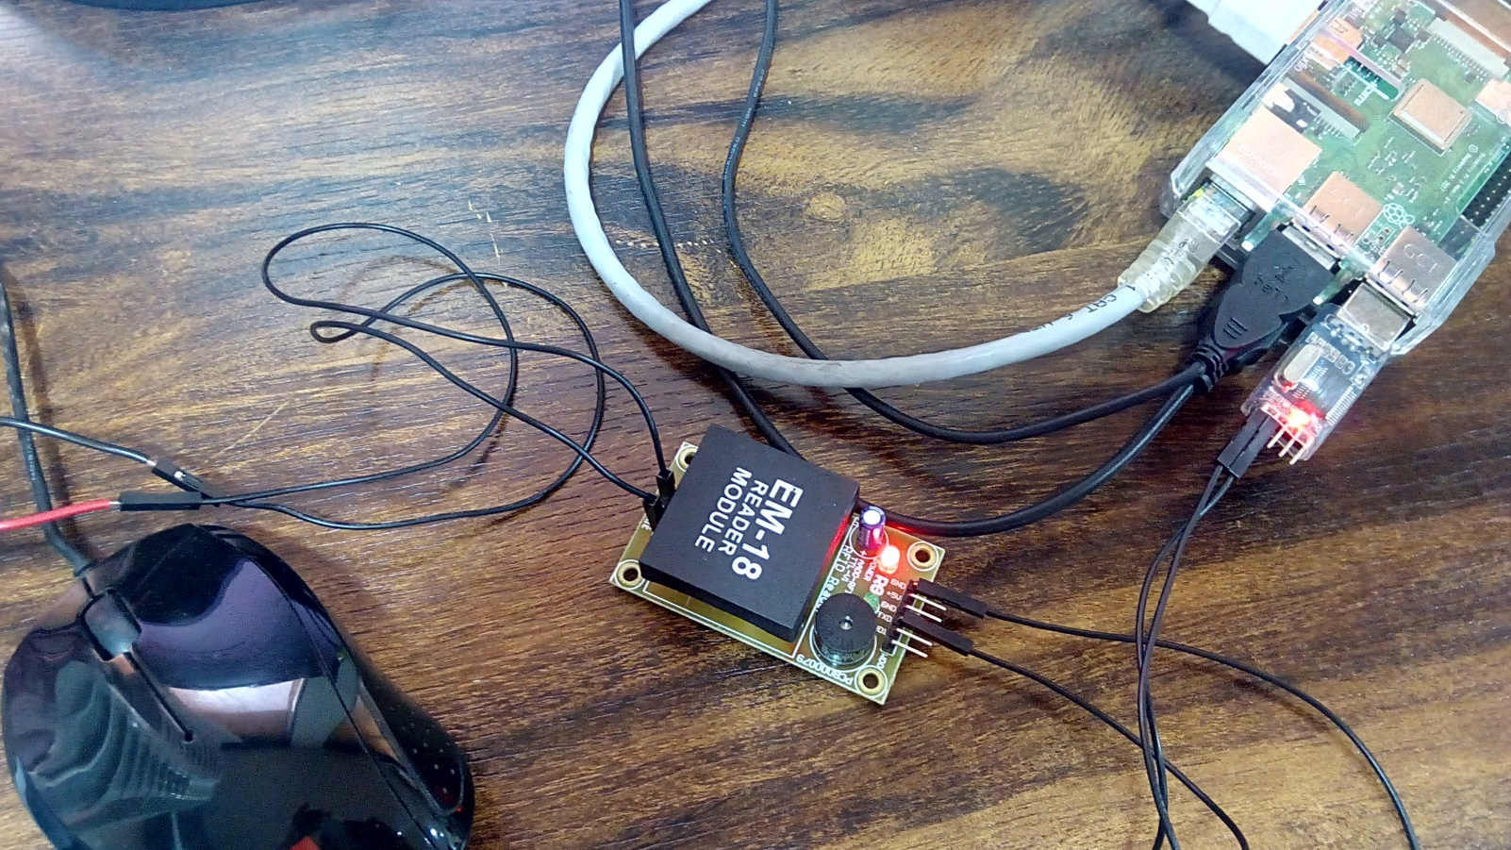

**Practical 8**

**Aim:**

**Installing Windows 10 IoT Core on Raspberry Pi**

**Additional Hardware Required:**

1. Class 10 microSD card
2. Card Reader

**Software Configuration required:**

Do the following on your Windows machine or laptop.

1: open browser and open following link

<https://developer.microsoft.com/en-us/windows/iot/Downloads.htm>

2: Click **Get Windows 10 IoT Core Dashboard** to download the necessary application

It will download setup.exe

3: Run that exe and install it and open it.

4: Select **set up a new device** from the sidebar

5: Select the options as shown in the image below. Make sure you select the correct drive for your microSD card and give your device a name and admin password.



6: Select the WiFi network connection you want your Raspberry Pi to connect to, if required. Only networks your PC connects to will be shown.

7: Click **download and install**.

The application will now download the necessary files from Microsoft and flash them to your microSD card.



8: Once the image has been installed on the microSD card, it's time to eject it from your PC and go over to the Raspberry Pi.

9: Insert the microSD card into the Raspberry Pi and power it up.

**Practical 9**

**Aim:**

**Raspberry Pi Based Oscilloscope**

**Additional Hardware required:**

1. ADS1115 ADC
2. Jumper wires
3. Potentiometer (pot)

**ADS1115 and Raspberry Pi Connections:**

VDD – 3.3v (pin 1 on pi)

GND – GND (pin 6 of Pi)

SDA – SDA (pin 3 of pi)

SCL – SCL (pin 5 of pi)

**Connect Potentiometer on breadboard**

Connect 1st hole to pin 17 (3.3v ) on pi

Connect 2nd hole to pin A0 on ADS115 module

Connect 3rd hole to pin 39 (GND) on ip.

**Software Configuration required:**

**Install Dependencies for Raspberry Pi Oscilloscope:**

**Step 1: Enable Raspberry Pi I2C interface**

To enable the I2C, from the terminal, run;

**sudo raspi-config**

When the configuration panels open, select interface options, select I2C and click enable

**Step 2: Update the Raspberry pi**

To do this, run below two commands:

**sudo apt-get update**

**sudo apt-get upgrade**

**Step 3: Install the Adafruit ADS1115 library for ADC**

Ensure you are in the Raspberry Pi home directory by running;

**cd ~**

Then install the build-essentials by running;

**sudo apt-get install build-essential python-dev python-smbus git**

clone the Adafruit git folder for the library by running;

**git clone https://github.com/adafruit/Adafruit_Python_ADS1x15.git**

Change into the cloned file’s directory and run the setup file;

**cd Adafruit_Python_ADS1x15**

**sudo python setup.py install**

**Step 4: Test the library and 12C communication.**

While still in the Adafruit_Python_ADS1x15 folder, change directory to the examples directory by running;

**cd examples**

Next, run the sampletest.py example which displays the value of the four channels on the ADC in a tabular form.

**Run the example using:**

**python simpletest.py**

**Step 5: Install *Matplotlib***

To visualize the data we need to install the *matplotlib* module which is used to plot all kind of graphs in python. This can be done by running;

**sudo apt-get install python-matplotlib**

**Step6: Install the *Drawnow* python module**

This module helps us provide live updates to the data plot.

We will be installing *drawnow* via the python package installer; *pip*, so we need to ensure it is installed. This can be done by running;

**sudo apt-get install python-pip**

We can then use pip to install the *drawnow* package by running:

**sudo pip install drawnow**

**Write following code in python 2 IDLE and save it as ‘osci.py’**

**Raspberry Pi Oscilloscope Code:**

import time

import matplotlib.pyplot as plt

from drawnow import *

import Adafruit_ADS1x15

adc = Adafruit_ADS1x15.ADS1115()

GAIN = 1

val = [ ]

cnt = 0

plt.ion()

adc.start_adc(0, gain=GAIN)

print('Reading ADS1x15 channel 0')

def makeFig():

plt.ylim(-5000,5000)

plt.title('Osciloscope')

plt.grid(True)

plt.ylabel('ADC outputs')

plt.plot(val, 'ro-', label='Channel 0')

plt.legend(loc='lower right')

while (True):

value = adc.get_last_result()

print('Channel 0: {0}'.format(value))

time.sleep(0.5)

val.append(int(value))

drawnow(makeFig)

plt.pause(.000001)

cnt = cnt+1

if(cnt>50):

val.pop(0)

**output:**

